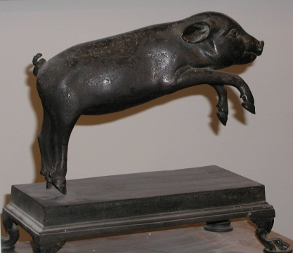

Gift Aid Declaration

The Herculaneum Society (reg. charity number 1104632)

Please treat as Gift Aid donations all qualifying gifts of money made
today □ in the past 4 years □ in the future □
Please tick all boxes you wish to apply.

I confirm that I have paid or will pay an amount of Income Tax and/or Capital Gains Tax for each tax year (6 April to 5 April) that is at least equal to the amount of tax that all the charities or Community Amateur Sports Clubs that I donate to will reclaim on my gifts for that tax year. I understand that other taxes such as VAT and Council Tax do not qualify. I understand the charity will reclaim 25p of tax on every £1 that I give.

Donor’s details
Title _______ First name or initial(s) _______________________________
Surname _______________________________________________________
Full home address ________________________________________________
_______________________________________________________________
Postcode _____________________
Date _____________________
Signature ____________________________________

Please notify us (herculaneum@classics.ox.ac.uk; 66 St. Giles, Oxford OX1 3LU; tel. 01865 288260) if you:
- want to cancel this declaration
- change your name or home address
- no longer pay sufficient tax on your income and/or capital gains
If you pay Income Tax at the higher or additional rate and want to receive the additional tax relief due to you, you must include all your Gift Aid donations on your Self Assessment tax return or ask HM Revenue and Customs to adjust your tax code.

